Glue Guru

SAFETY DATA SHEET

Section 1. Identification of the material and the supplier

Product: Bit-U-Prime - Canister
Size: 17.0 kg
Product Use: Industrial Adhesive

New Zealand Supplier: Glue Guru
Address: 1016E Great South Rd
Penrose, Auckland
Telephone: 64 9 444 4878
Fax Number: 64 9 442 5975
NZ Emergency No: 0800 766 764 (National Poison Centre)

Australian Supplier: Glue Guru
Address: 1/21 Leakes Road
Laverton North, VIC
Australia
Telephone No: 1300 901 687
E-mail: enquiries@glueguru.com.au

Australian Emergency No 13 11 26 (National Poison Centre)

Date of MSDS Preparation: 12 June 2025

Section 2. Hazards Identification

Australia:
Classified as Hazardous according to the Globally Harmonised System of Classification and labelling of Chemicals (GHS) including Work, Health and Safety regulations, Australia

New Zealand:
This substance is hazardous according to the EPA Hazardous Substances (Classification)
Notice 2020

EPA Approval Code: Gases Under Pressure Mixtures (Flammable) – HSR0002532

Pictograms:
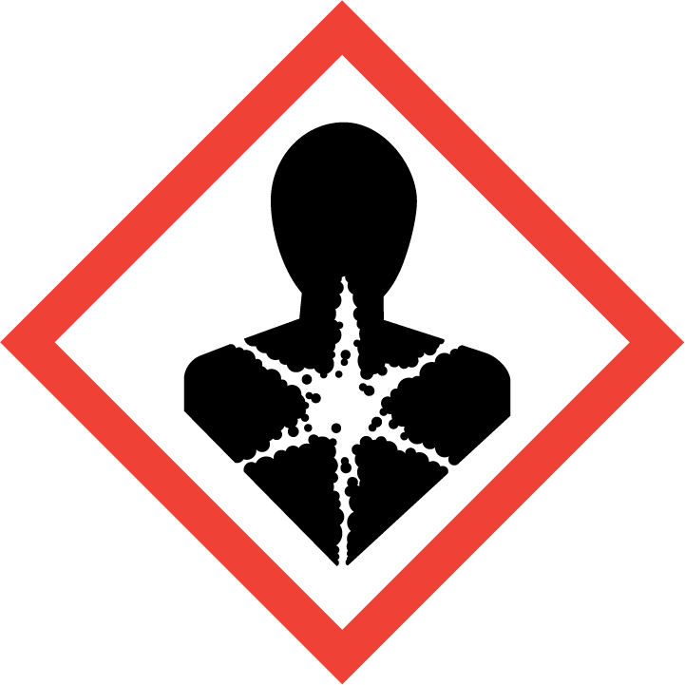


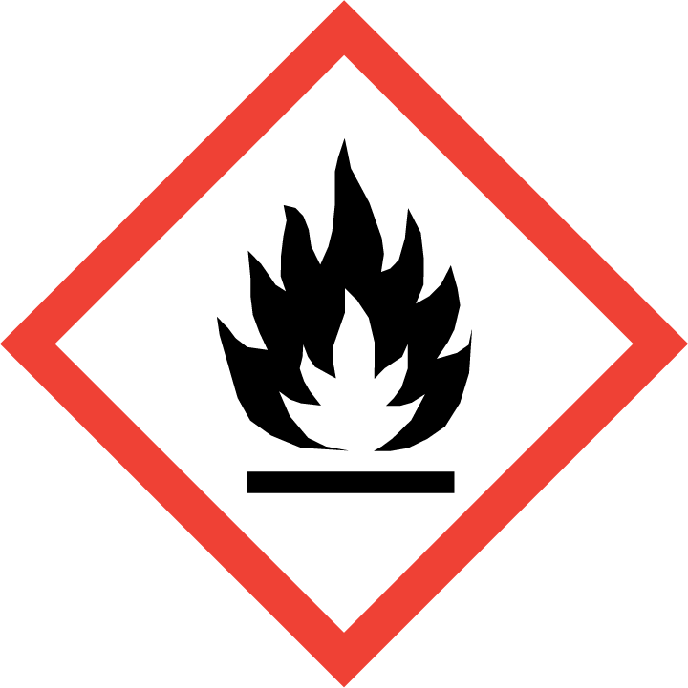

Signal Word: DANGER

GHS Classification and Category | Hazard Code | Hazard Statement
Flammable gas Cat. 1A | H220 | Extremely flammable gas.
Liquified Gas | H280 | Contains gas under pressure may explode if heated.
Skin irritation Cat. 2 | H315 | Causes skin irritation.
Eye irritation Cat. 2 | H319 | Causes serious eye irritation.
Carcinogenicity Cat. 2 | H351 | Suspected of causing cancer.
Specific target organ toxicity – repeated exposure Cat. 2 | H373 | May cause damage to organs through prolonged or repeated exposure.

Prevention Code | Prevention Statement
P103 | Read carefully and follow all instructions.
P201 | Obtain special instructions before use.
P202 | Do not handle until all safety precautions have been read and understood.
P210 | Keep away from heat, hot surfaces, sparks, open flames and other ignition sources. No smoking.
P260 | Do not breathe fumes, gas, mist, vapours or spray.
P264 | Wash hands thoroughly after handling.
P270 | Do not eat, drink or smoke when using this product.
P280 | Wear protective clothing as detailed in SDS Section 8.

Response Code | Response Statement
P314 | Get medical advice/attention if you feel unwell.
P377 | Leaking gas fire: Do not extinguish, unless leak can be stopped safely.
P381 | In case of leakage, eliminate all ignition sources.
P302 + P352 | IF ON SKIN: Wash with plenty of water.
P305 + P351+P338 | IF IN EYES: Rinse cautiously with water for several minutes. Remove contact lenses, if present and easy to do. Continue rinsing.
P308 + P313 | IF exposed or concerned: Get medical advice/ attention.
P332 + P313 | If skin irritation occurs: Get medical advice/ attention.
P337 + P313 | If eye irritation persists: Get medical advice/attention.
P362+P364 | Take off contaminated clothing and wash before reuse.

Storage Code | Storage Statement
P403 | Store in a well-ventilated place.
P405 | Store locked up.
P410 + P403 | Protect from sunlight. Store in a well-ventilated place.

Disposal Code | Disposal Statement
P501 | Dispose of according to Local Regulations or Authorities

Section 3. Composition of hazardous Ingredients

Ingredients | Wt% | CAS NUMBER.
dichloromethane | <30 | 75-09-2
Propane | <15 | 74-98-6
Isobutane | <15 | 75-28-5
Bitumen | 10 | 8052-42-4

Section 4. First Aid Measures

Routes of Exposure:

If in Eyes Hold eyelids apart and flush eyes with plenty of water for at least 15 minutes. Remove contact lenses, if present and easy to do. Continue rinsing. If irritation develops and persists, get medical attention.

If on Skin Wash skin with plenty of water. Take off contaminated clothing. If skin irritation or rash occurs: Get medical advice/attention.

If Swallowed DO NOT induce vomiting. Wash out mouth thoroughly with water. Never give anything to the mouth of an unconscious person. Seek medical attention if needed.

If Inhaled Remove person to fresh air. Remove contaminated clothing and loosen remaining clothing. Allow person to assume most comfortable position and keep warm. Keep at rest until fully recovered. Immediately call a POISON CENTER or doctor/physician.
Most important symptoms and effects, both acute and delayed
Symptoms:
Swallowed: Not applicable.
Inhalation: Not applicable.
Skin: Causes skin irritation.
Eyes: Causes serious eye irritation.
Chronic: Suspected of causing cancer. May cause damage to organs through prolonged or repeated exposure.

Notes to Doctor: Upon exposure to Dichlormethane: Do not administer any preparations of the adrenaline-ephedrine group.

Section 5. Fire Fighting Measures

Hazard Type | Extremely flammable gas.
Hazards from products | May decompose in a fire, giving off toxic and irritant vapours. Hazardous decomposition product(s): Hydrogen chloride, carbon oxides, Phosgene, Chlorine
Suitable Extinguishing media | Dry chemical, CO2, or water spray or regular foam. Do not use a heavy water stream. Direct waterjet may spread the fire.
Precautions for firefighters and special protective clothing | Fire fighters should wear complete protective clothing including self-contained breathing apparatus. Do not breathe fumes. If possible remove containers before using water. Keep containers cool by spraying with water if exposed to fire.  In case of fire, stop leak if safe to do so. Vapours are heavier than air and may travel considerable distances to a source of ignition and flashback.
HAZCHEM CODE | 2YE

Section 6. Accidental Release Measures

Measures for personal safety:
Wear personal protective equipment. Where excessive vapour, mist, or dust may result, use
approved respiratory protection equipment. No flames, no sparks. Eliminate all sources of
ignition. No open flames, no sparks, and no smoking. Do not breathe vapours, mist, spray. Avoid contact with skin and eyes. Evacuate unnecessary personnel. Provide adequate ventilation.

Environmental measures:
Do not allow to enter drains or water courses. Any large spillage into watercourses must be alerted to the regulatory authority regulatory body.

Methods and material for containment and cleaning up:
Allow small spillages to evaporate provided there is adequate ventilation. Do not pierce or burn container, even after use. Containers of this material may be hazardous when empty since they retain product residue. Soak up spills with inert solids, such as clay or diatomaceous earth as soon as possible. Place in a suitable container for disposal in accordance with the waste regulations (see Section 13).

Section 7. Handling and Storage

Precautions for Handling:
- Read carefully and follow all instructions.
- Obtain special instructions before use.
- Do not handle until all safety precautions have been read and understood.
- Keep away from heat, hot surfaces, sparks, open flames and other ignition sources. No
smoking.
- Do not breathe fumes, gas, mist, vapours or spray.
- Wash hands thoroughly after handling.
- Do not eat, drink or smoke when using this product.
- Wear protective clothing as detailed in SDS Section 8.
- Ensure good ventilation of the workstation.
- Do not spray on an open flame or other ignition source.
- Pressurized container. Protect from sunlight and do not expose to temperatures
exceeding 50°C.
- Avoid contact with skin and eyes.
- Do not eat, drink or smoke when using this product.
- Keep away from direct sunlight.

Precautions for Storage:
- Store away from incompatible materials: Acids, Bases, Strong oxidising agents. Avoid contact with alkali metals.
- Store locked up.
- Protect from sunlight.
- Keep only in original container.
- Store in a cool/low-temperature, well-ventilated (dry) place away from heat and ignition sources.
- Opened containers should be carefully resealed and stored in an upright position.
- Store at room temperature.

Section 8 Exposure Controls / Personal Protection

WORKPLACE EXPOSURE STANDARDS (provided for guidance only)

TWA STEL
Substance ppm mg/m³ ppm mg/m³

Methylene chloride (Dichloromethane) [75-09-2] 50 174 - -
Asphalt (petroleum) fumes [8052-42-4] - 0.5 - -

Workplace Exposure Standard – Time Weighted Average (WES-TWA). The time-weighted average exposure standard designed to protect the worker from the effects of long-term exposure. Workplace Exposure Standard – Short-Term Exposure Limit (WESSTEL). The 15-minute average exposure standard. Applies to any 15- Minute period in the working day and is designed to protect the worker against adverse effects of irritation, chronic or irreversible tissue change, or narcosis that may increase the likelihood of accidents. The WES-STEL is not an alternative to the WES-TWA; both the short-term and time-weighted average exposures apply. Workplace Exposure Standards and Biological Exposure Indices FEB 2025 15TH EDITION.

Engineering Controls
Ensure adequate ventilation. Store in a cool/low-temperature, well-ventilated (dry) place away from heat and ignition sources.

Personal Protection Equipment


Eyes | Wear protective safety goggles EN166
Hands | Wear impervious gloves (EN374). Breakthrough time of the glove material: refer to the information provided by the gloves’ producer.
Skin | Wear suitable protective clothing. Overall. Standard. EN 13034
Respiratory | In case of inadequate ventilation wear respiratory protection. A suitable mask with filter type AX may be appropriate.
General | Keep good industrial hygiene. Wear appropriate personal protective equipment, avoid direct contact. Avoid breathing gas. IF exposed: Wash immediately with water. Wash contaminated clothing before reuse. Do not eat, drink or smoke at the work place.

Section 9 Physical and Chemical Properties

Appearance | Liquid in a Gas Canister
Colour | Black
Odour | Solvent/bitumen odour
Odour Threshold | Asphalt
pH | Not available
Boiling Point | 40⁰C
Melting Point | -97⁰C
Freezing Point | Not available
Flash Point | -90 °C - [Closed cup]
Flammability | Not available
Upper and Lower Explosive Limits | 12% - 19%
Vapour Pressure | 70 psig @ 21.1 °C
Vapour Density | (Air=1) 2.15
Relative Density | 1.3 g/mL @ 25 °C
Water Solubility | Insoluble (Hansen solubility test parameter)
Partition Coefficient: | Log Pow: 1.25
Auto-ignition Temperature | > 556.1 °C
Decomposition Temperature | Not available
Kinematic Viscosity | Not available
Particle Characteristics | Not available

Section 10. Stability and Reactivity

Stability of Substance | This product is stable under normal conditions.
Reactivity | Extremely flammable aerosol. Pressurised container: May burst if heated.
Possibility of hazardous reactions | Stable under normal conditions. Hazardous polymerisation will not occur.
Conditions to Avoid | Keep away from heat, hot surfaces, sparks, open flames and other ignition sources. No smoking. Keep from direct sunlight. Keep away from: Elevated temperature. Do not spray on an open flame or other ignition source.
Incompatible Materials | Acids, Bases, Strong oxidising agents. Avoid contact with alkali metals.
Hazardous Decomposition  Products | May decompose in a fire, giving off toxic and irritant vapours. Hazardous decomposition product(s): Hydrogen chloride, carbon oxides, Phosgene, Chlorine

Section 11 Toxicological Information

Acute Effects:

Swallowed | Not applicable.
Dermal | Not applicable.
Inhalation | Not applicable.
Eye | Causes serious eye irritation.
Skin | Causes skin irritation.

Chronic Effects:

Carcinogenicity | Suspected of causing cancer.
Reproductive Toxicity | Not applicable.
Germ Cell Mutagenicity | Not applicable.
Aspiration | Not applicable.
STOT/SE | Not applicable.
STOT/RE | May cause damage to organs through prolonged or repeated exposure.

Section 12. Ecotoxicological Information

Not classified as hazardous to the aquatic environment.

Product:
Persistence and degradability | Biodegradability < 26 % - Not readily biodegradable. (OECD 301C – Mixture)
Bioaccumulation | The product has no potential for bioaccumulation.
Mobility in Soil | The product is predicted to have low mobility in soil. Insoluble in water.
Other adverse effects | No data available

Section 13. Disposal Considerations

Disposal Method:
Dispose of this material and its container to hazardous or special waste collection point. Do
Make sure that packaging is completely empty before recycling. Containers of this material may
be hazardous when empty since they retain product residue.
Precautions or methods to avoid: Container under pressure. Do not drill or burn even after
use.

Section 14 Transport Information

This product is classified as Dangerous Goods according to the Australian Code for the Transport of Dangerous Goods by Road and Rail (ADG Code) (7th edition).

This product is classified as a Dangerous Good for transport in NZ ; NZS 5433:2020 and SNZ HB 5433:2021
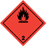
Road, Rail, Sea and Air Transport

UN No | 3501
Class - Primary | 2.1
Packing Group | N/A
Proper Shipping Name | CHEMICAL UNDER PRESSURE, FLAMMABLE, N.O.S. (isobutane ;  propane)
Marine Pollutant | No
Special Provisions | 274, 362

Section 15 Regulatory Information

Australia:
Classified as Hazardous according to the Globally Harmonised System of Classification and labelling of Chemicals (GHS) including Work, Health and Safety regulations, Australia

Classified as a Schedule 5 Poison according to the Standard for the Uniform Scheduling of Medicines and Poisons (SUSMP).

New Zealand:
This substance is hazardous according to the EPA Hazardous Substances (Classification)
Notice 2020

EPA Approval Code: Gases Under Pressure Mixtures (Flammable) – HSR0002532

HSW (HS) Regulations 2017 and EPA Notices | Trigger Quantity
Certified Handler | Not required
Location Certificate | 100kg
Tracking Trigger Quantities | Not required
Signage Trigger Quantities | 250kg
Emergency Response Plan | 300kg
Secondary Containment | 300kg
Fire Extinguisher | 50kg = 1 off
Restriction of Use | Only use for the intended purpose.

Section 16 Other Information

Glossary
Cat Category
EC₅₀ Median effective concentration.
EEL Environmental Exposure Limit.
EPA Environmental Protection Authority
HSNO Hazardous Substances and New Organisms.
HSW Health and Safety at Work.
LC₅₀ Lethal concentration that will kill 50% of the test organisms inhaling or ingesting it.
LD₅₀ Lethal dose to kill 50% of test animals/organisms.
LEL Lower explosive level.
OSHA American Occupational Safety and Health Administration.
TEL Tolerable Exposure Limit.
TLV Threshold Limit Value-an exposure limit set by responsible authority.
UEL Upper Explosive Level
WES Workplace Exposure Limit

References:
Australia:
- Preparation of Safety Data Sheets for Hazardous Chemicals Code of Practice.
- Standard for the Uniform Scheduling of Medicines and Poisons.
- Australian Code for the Transport of Dangerous Goods by Road & Rail.
- Model Work Health and Safety Regulations, Schedule 10: Prohibited carcinogens,
restricted carcinogens and restricted hazardous chemicals.
- Workplace exposure standards for airborne contaminants, Safe work Australia.
- American Conference of Industrial Hygienists (ACGIH).
- Globally Harmonised System of classification and labelling of chemicals.

New Zealand:
- EPA Hazardous Substances (Safety Data Sheets) Notice 2017
- Workplace Exposure Standards and Biological Exposure Indices FEB 2025 15th edition.
- Assigning a hazardous substance to a HSNO Approval (Aug 2013).
- Transport of Dangerous goods on land NZS 5433:2020
- HSW (Hazardous Substances) Regulations 2017

Disclaimer
This document has been issued by the Glue Guru and serves as their Safety Data Sheet ('SDS'). It is based on information concerning the product which has been provided to the Glue Guru or obtained from third party sources and is believed to represent the current state of knowledge as to the appropriate safety and handling precautions for the product at the time of issue. Further clarification regarding any aspect of the product should be obtained directly from the manufacturer. While Glue Guru have taken all due care to include accurate and up-to-date information in this SDS, it does not provide any warranty as to accuracy or completeness. As far as lawfully possible, Glue Guru accept no liability for any loss, injury or damage (including consequential loss) which may be suffered or incurred by any person as a consequence of their reliance on the information contained in this SDS
The information herein is given in good faith, but no warranty, express or implied is made.
Please contact the New Zealand distributor, Glue Guru, if further information is required.

Issue Date: 22 May 2025 Review Date: 22 May 2030

