Glue Guru

SAFETY DATA SHEET

Section 1. Identification of the material and the supplier

Product: Poly-Tac Aerosol
Size:
Product Use: Industrial Adhesives
Restriction of Use: Refer to Section 15

New Zealand Supplier: Glue Guru
Address: 1016E Great South Road
Penrose, Auckland, 1061
Telephone: 09 444 4878
Fax Number: 09 442 5975
NZ Emergency No: 0800 764 766(National Poison Centre)

Australian Supplier: Glue Guru International Ltd
Address: 1/21 Leakes Road
Laverton North
Melbourne, VIC
Australia
Telephone No: 1300 901 687

Australian Emergency No 13 11 26 (National Poison Centre)

Date of SDS Preparation: 12 June 2025

Section 2. Hazards Identification

Australia:
Classified as Hazardous according to the Globally Harmonised System of Classification and labelling of Chemicals (GHS) including Work, Health and Safety regulations, Australia

New Zealand:
This substance is hazardous according to the EPA Hazardous Substances (Classification)
Notice 2020

EPA Approval Code: Aerosols (Flammable) – HSR0002515

Pictograms:

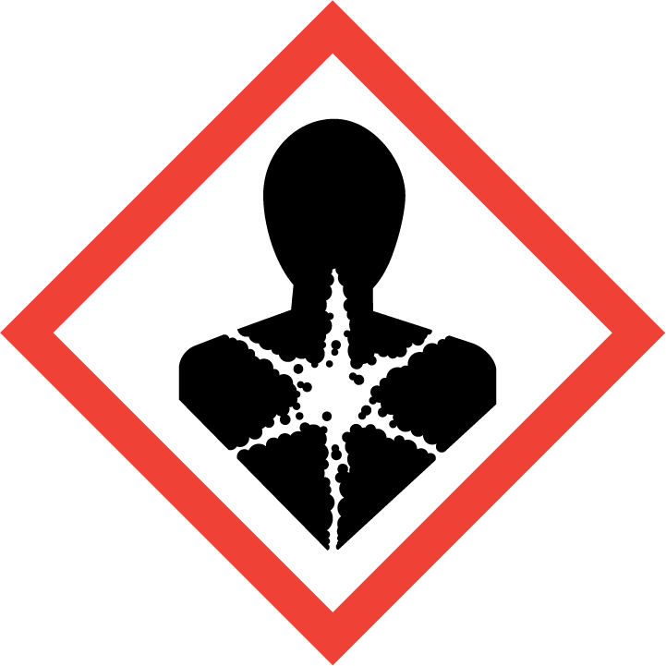
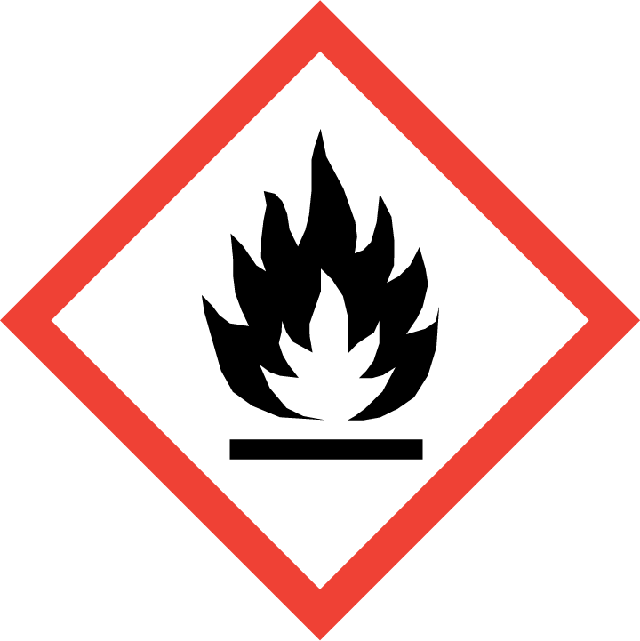

Signal Word: DANGER

GHS Classification and Category | Hazard Code | Hazard Statement
Aerosol Cat. 1 | H222 | Extremely flammable aerosol.
Aerosol Cat. 1 | H229 | Pressurized container: May burst if heated.
Specific target organ toxicity – repeated exposure Cat. 1 | H372 | Causes damage to organs through prolonged or repeated exposure.
Hazardous to the aquatic environment chronic Cat. 3 | H412 | Harmful to aquatic life with long lasting effects.

Prevention Code Prevention Statement
P103 | Read carefully and follow all instructions.
P210 | Keep away from heat, hot surfaces, sparks, open flames and other ignition sources. No smoking.
P211 | Do not spray on an open flame or other ignition source.
P251 | Do not pierce or burn, even after use.
P260 | Do not breathe fumes, gas, mist, vapours or spray.
P264 | Wash hands thoroughly after handling.
P270 | Do not eat, drink or smoke when using this product.
P273 | Avoid release to the environment.

Response Code Response Statement
P314 | Get medical advice/attention if you feel unwell.

Storage Code Storage Statement
P410 + P412 | Protect from sunlight. Do not expose to temperatures exceeding 50 °C.

Disposal Code Disposal Statement
P501 | Dispose of according to the local authorities

Section 3. Composition of hazardous Ingredients

Ingredients | Wt% | CAS NUMBER.
n-hexane | <5 | 110-54-3
Acetone | <5 | 67-64-1
Butane | 10-15 | 106-97-8
Isobutane | 10-15 | 75-28-5

Section 4. First Aid Measures

Routes of Exposure:

If in Eyes Rinse cautiously with water for several minutes. If eye irritation persists: Get medical advice/attention.

If on Skin Wash skin with soap and water. Launder soaked clothing before reuse. Seek medical assistance if needed.

If Swallowed Do NOT induce vomiting. If vomiting occurs turn patient on side. IF exposed or concerned: Call a POISON CENTER/doctor.

If Inhaled Remove persons affected by vapour to fresh air. Apply artificial
respiration if patient is not breathing. If experiencing respiratory symptoms: Call a POISON CENTER/doctor.

Most important symptoms and effects, both acute and delayed:
Symptoms: May cause damage to organs through prolonged or repeated exposure

Section 5. Fire Fighting Measures

Hazard Type | Extremely flammable Aerosol
Hazards from products | No data available.
Suitable Extinguishing media | Water spray, foam, dry powder or CO2
Precautions for firefighters and special protective clothing | Wear self-contained breathing apparatus for firefighting if necessary. Use water spray to cool unopened containers.
HAZCHEM CODE | 2YE

Section 6. Accidental Release Measures

Use personal protective equipment as detailed in Section 8. Avoid breathing vapours or gas. Ensure adequate ventilation. Remove all ignition sources. Keep away from heat, hot surfaces, sparks, open flames and other ignition sources. No smoking. Evacuate non-essential personnel.

Do not allow to enter drains, sewers or watercourses.

Contain and collect spillage with non-combustible, absorbent material e.g. sand, earth, vermiculite or diatomaceous earth. Place into a container for disposal. Dispose as per Section 13.

Section 7. Handling and Storage

Handling:
- Read carefully and follow all instructions.
- Keep away from heat, hot surfaces, sparks, open flames and other ignition sources. No smoking.
- Do not spray on an open flame or other ignition source.
- Do not pierce or burn, even after use.
- Do not breathe dust, fumes, gas, mist, vapours or spray.
- Wash hands thoroughly after handling.
- Do not eat, drink or smoke when using this product.
- Avoid release to the environment.
- Avoid contact with skin and eyes.
- Flash back is possible over considerable distance.
- Container explosion may occur under fire conditions.
- Eating, drinking and smoking should be prohibited in areas where this material is handled, stored and processed.

Storage:
- Store in a cool place.
- Store in a well-ventilated place.
- Keep container tightly closed.
- Protect from sunlight. Do not expose to temperatures exceeding 50 °C.
- Containers which are opened must be carefully resealed and kept upright to prevent leakage.

Section 8 Exposure Controls / Personal Protection

WORKPLACE EXPOSURE STANDARDS (provided for guidance only)

TWA STEL
Substance ppm mg/m³ ppm mg/m³

Hexane (n-Hexane) [110-54-3] 20 72 - -
Acetone [67-64-1] 500 1185 1000 2375
Butane [106-97-8] 800 1900 - -

Workplace Exposure Standard – Time Weighted Average (WES-TWA). The time-weighted average exposure standard designed to protect the worker from the effects of long-term exposure. Workplace Exposure Standard – Short-Term Exposure Limit (WESSTEL). The 15-minute average exposure standard. Applies to any 15- Minute period in the working day and is designed to protect the worker against adverse effects of irritation, chronic or irreversible tissue change, or narcosis that may increase the likelihood of accidents. The WES-STEL is not an alternative to the WES-TWA; both the short-term and time-weighted average exposures apply. Workplace Exposure Standards and Biological Exposure Indices FEB 2025 15TH EDITION.

Engineering Controls
Provide adequate ventilation. Where reasonably practicable, this should be achieved by the use
of local exhaust ventilation and good general extraction

Personal Protection Equipment


Eyes | If there is a risk to eyes use safety glasses & goggles to approved standard such as EN166(EU)
Hands | Wear impervious gloves (EN374).
Skin | Use impervious overalls.
Respiratory | Independent air fed respirators must be worn when handling this product where adequate ventilation is not available or there is a risk of the WEL being exceeded.
General | Keep good industrial hygiene. Wear appropriate personal protective equipment, avoid direct contact. Avoid breathing gas. IF exposed: Wash immediately with water. Wash contaminated clothing before reuse. Do not eat, drink or smoke at the workplace.

Section 9 Physical and Chemical Properties

Appearance | Aerosol
Colour | Clear/Blue
Odour | Solvent odour
Odour Threshold | Asphalt
pH | 7 @ 5g/l @ 20 °C
Boiling Point | 69ºC
Melting Point | -95 °C
Freezing Point | Not applicable
Flash Point | -25.99 °C
Flammability | Highly Flammable Gas
Upper and Lower Explosive Limits | 1.2 – 7.7%
Vapour Pressure | Not available
Vapour Density | Not available
Relative Density | 0.65 g/mL at 25 °C
Solubilities | insoluble
Partition Coefficient | Not available
Auto-ignition Temperature | 234.0⁰C
Decomposition Temperature | Not applicable
Kinematic Viscosity | Not applicable
Particle Characteristics | Not applicable

Section 10. Stability and Reactivity

Stability of Substance | This product is stable under normal conditions.
Possibility of hazardous reactions | Under normal conditions of storage and use, hazardous reactions will not occur.
Conditions to Avoid | Heat, flames and other sources of ignition.
Incompatible Materials | Keep away from the following materials to prevent strong exothermic reactions: oxidising agents
Hazardous Decomposition  Products | Under normal conditions of storage and use, hazardous decomposition products should not be produced.

Section 11 Toxicological Information

Acute Effects:

Oral | Not applicable.
Dermal | Not applicable.
Inhalation | Not applicable.
Eye | Not applicable.
Skin | Not applicable.

Chronic Effects:

Carcinogenicity | Not applicable.
Reproductive Toxicity | Not applicable.
Germ Cell Mutagenicity | Not applicable.
Aspiration | Not applicable.
STOT/SE | Not applicable.
STOT/RE | Causes damage to organs through prolonged or repeated exposure.

Individual component information:
Acute Toxicity:
Chemical Name | Oral – LD50 | Dermal – LD50 | Inhalation – LC50
Acetone | 5800 mg/kg (rat) | 7426 mg/kg (guinea pig) | 50100 mg/m3/8h (Rat)
Butane | - | - | 658 000 mg/m3/4h (rat)
n-Hexane | 25000 mg/kg (rat) | - | 48000 ppm/4h (rat)

Section 12. Ecotoxicological Information

Harmful to aquatic life with long lasting effects.

Persistence and degradability | No data available
Bioaccumulation | No data available
Mobility in Soil | No data available
Other adverse effects | No data available

Toxicity:
Acetone
Toxicity to fish LC50 - Oncorhynchus mykiss (rainbow trout) - 5,540 mg/l - 96 h
Toxicity to daphnia and other aquatic invertebrates
LC50 - Daphnia magna (Water flea) - 8,800 mg/l - 48 h

n-Hexane
Toxicity to fish LC50 - Pimephales promelas (fathead minnow) - 2.5 mg/l - 96.0 h
Toxicity to daphnia and other aquatic invertebrates EC50 - Daphnia magna (Water flea) - 3,878.00 mg/l - 48 h
Toxicity to algae EC50 - Chlorella vulgaris (Fresh water algae) - 12,840.00 mg/l - 3 h
EC50 - SKELETOMA - 0.30 mg/l - 8 h

Do not allow to enter waterways.

Section 13. Disposal Considerations

Dispose of this material and its container to hazardous or special waste collection point.
Precautions or methods to avoid: Pressurized container: May burst if heated. Do not drill or burn even after use.

Section 14 Transport Information

This product is classified as Dangerous Goods according to the Australian Code for the Transport of Dangerous Goods by Road and Rail (ADG Code) (7th edition).

This product is classified as a Dangerous Good for transport in NZ; NZS 5433:2020
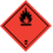

Road, Rail, Sea and Air Transport

UN No | 1950
Class - Primary | 2
Packing Group | N/A
Proper Shipping Name | AEROSOLS
Marine Pollutant | No
Special Provisions | 63, 190, 277, 344, 327

Section 15 Regulatory Information

Australia:
Classified as Hazardous according to the Globally Harmonised System of Classification and labelling of Chemicals (GHS) including Work, Health and Safety regulations, Australia

Not classified as a Scheduled Poison according to the Standard for the Uniform Scheduling of Medicines and Poisons (SUSMP).

New Zealand:
This substance is hazardous according to the EPA Hazardous Substances (Classification) Notice 2020

EPA Approval Code: Aerosols (Flammable) – HSR0002515

Trigger Quantities for this substance:
HSW (HS) Regulations 2017 and EPA Notices | Trigger Quantity
Certified Handler | Not required
Location Certificate | 3000L AWC
Tracking Trigger Quantities | Not required
Signage Trigger Quantities | 3000L AWC
Emergency Response Plan | 1000L
Secondary Containment | 1000L
Fire Extinguisher | 3000L AWC = 1 off
Restriction of Use | Only use for the intended purpose.

Section 16 Other Information

Glossary
Cat Category
EC₅₀ Median effective concentration.
EEL Environmental Exposure Limit.
EPA Environmental Protection Authority
HSNO Hazardous Substances and New Organisms.
HSW Health and Safety at Work.
LC₅₀ Lethal concentration that will kill 50% of the test organisms inhaling or ingesting it.
LD₅₀ Lethal dose to kill 50% of test animals/organisms.
LEL Lower explosive level.
OSHA American Occupational Safety and Health Administration.
TEL Tolerable Exposure Limit.
TLV Threshold Limit Value-an exposure limit set by responsible authority.
UEL Upper Explosive Level
WES Workplace Exposure Limit

References:
Australia:
- Preparation of Safety Data Sheets for Hazardous Chemicals Code of Practice.
- Standard for the Uniform Scheduling of Medicines and Poisons.
- Australian Code for the Transport of Dangerous Goods by Road & Rail.
- Model Work Health and Safety Regulations, Schedule 10: Prohibited carcinogens,
restricted carcinogens and restricted hazardous chemicals.
- Workplace exposure standards for airborne contaminants, Safe work Australia.
- American Conference of Industrial Hygienists (ACGIH).
- Globally Harmonised System of classification and labelling of chemicals.

New Zealand:
- EPA Hazardous Substances (Safety Data Sheets) Notice 2017
- Workplace Exposure Standards and Biological Exposure Indices FEB 2025 15th edition.
- Assigning a hazardous substance to a HSNO Approval (Aug 2013).
- Transport of Dangerous goods on land NZS 5433:2020
- HSW (Hazardous Substances) Regulations 2017

Disclaimer
This document has been issued by the Glue Guru and serves as their Safety Data Sheet ('SDS'). It is based on information concerning the product which has been provided to the Glue Guru or obtained from third party sources and is believed to represent the current state of knowledge as to the appropriate safety and handling precautions for the product at the time of issue. Further clarification regarding any aspect of the product should be obtained directly from the manufacturer. While Glue Guru have taken all due care to include accurate and up-to-date information in this SDS, it does not provide any warranty as to accuracy or completeness. As far as lawfully possible, Glue Guru accept no liability for any loss, injury or damage (including consequential loss) which may be suffered or incurred by any person as a consequence of their reliance on the information contained in this SDS
The information herein is given in good faith, but no warranty, express or implied is made.
Please contact the New Zealand distributor, Glue Guru, if further information is required.

Issue Date: 12 June 2025 Review Date: 12 June 2030

