Glue Guru

SAFETY DATA SHEET

Section 1. Identification of the material and the supplier

Product: Roof-Tac Canister
Size: 17kg
Product Use: Industrial Adhesive

New Zealand Supplier: Glue Guru
Address: 1016E Great South Rd
Penrose, Auckland
Telephone: 64 9 444 4878
Fax Number: 64 9 442 5975
NZ Emergency No: 0800 766 764 (National Poison Centre)

Australian Supplier: Glue Guru
Address: 1/21 Leakes Road
Laverton North, VIC
Australia
Telephone No: 1300 901 687
E-mail: enquiries@glueguru.com.au

Australian Emergency No 13 11 26 (National Poison Centre)

Date of MSDS Preparation: 22 May 2025 v2

Section 2. Hazards Identification

Australia:
Classified as Hazardous according to the Globally Harmonised System of Classification and labelling of Chemicals (GHS) including Work, Health and Safety regulations, Australia

New Zealand:
This substance is hazardous according to the EPA Hazardous Substances (Classification)
Notice 2020

EPA Approval Code: Gases Under Pressure Mixtures (Flammable) – HSR0002532

Pictograms:
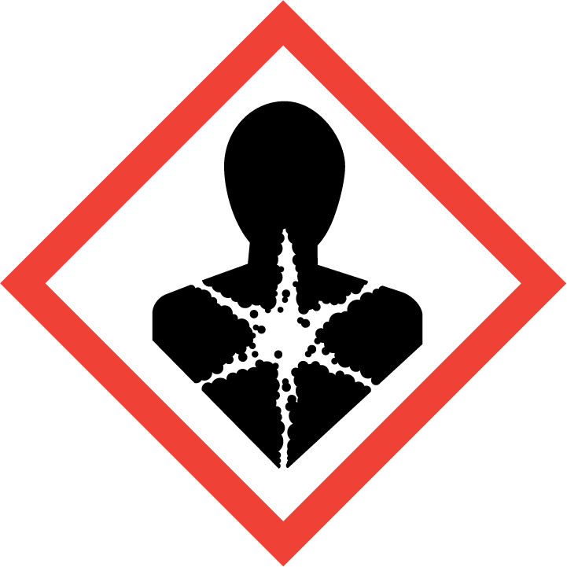

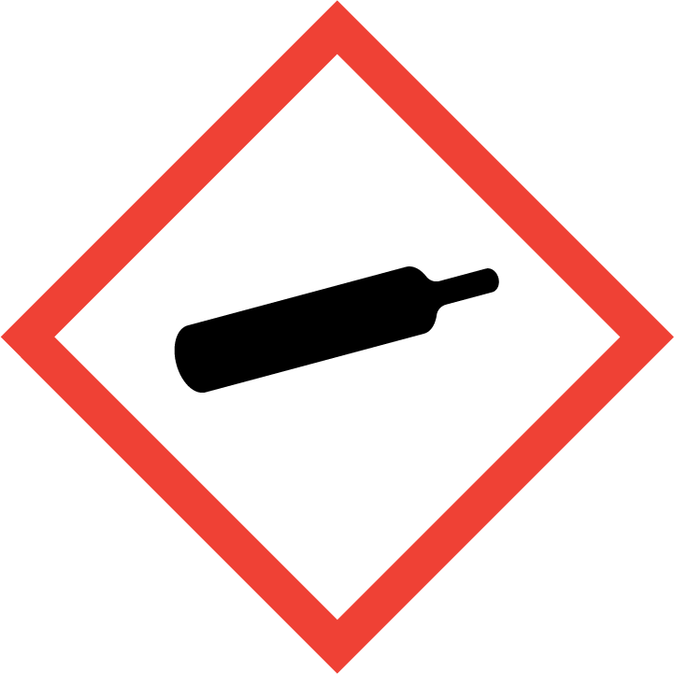
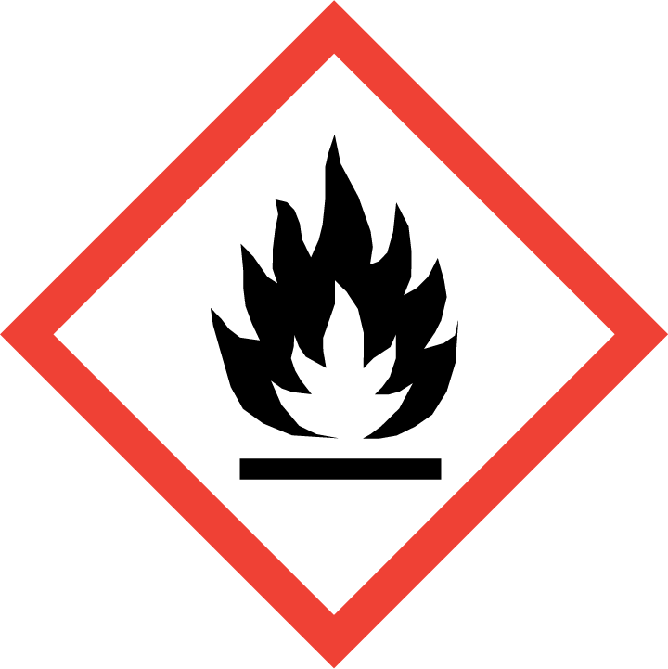

Signal Word: DANGER

GHS Classification and Category | Hazard Code | Hazard Statement
Flammable gas Cat. 1A | H220 | Extremely flammable gas.
Liquified Gas | H280 | Contains gas under pressure may explode if heated.
Skin irritation Cat. 2 | H315 | Causes skin irritation.
Eye irritation Cat. 2 | H319 | Causes serious eye irritation.
Carcinogenicity Cat. 2 | H351 | Suspected of causing cancer.
Specific target organ toxicity – repeated exposure Cat. 1 | H372 | Causes damage to organs through prolonged or repeated exposure.

Prevention Code | Prevention Statement
P103 | Read carefully and follow all instructions.
P201 | Obtain special instructions before use.
P202 | Do not handle until all safety precautions have been read and understood.
P210 | Keep away from heat, hot surfaces, sparks, open flames and other ignition sources. No smoking.
P260 | Do not breathe fumes, gas, mist, vapours or spray.
P264 | Wash hands thoroughly after handling.
P270 | Do not eat, drink or smoke when using this product.
P280 | Wear protective clothing as detailed in SDS Section 8.

Response Code | Response Statement
P314 | Get medical advice/attention if you feel unwell.
P377 | Leaking gas fire: Do not extinguish, unless leak can be stopped safely.
P381 | In case of leakage, eliminate all ignition sources.
P302 + P352 | IF ON SKIN: Wash with plenty of water.
P305 + P351+P338 | IF IN EYES: Rinse cautiously with water for several minutes. Remove contact lenses, if present and easy to do. Continue rinsing.
P308 + P313 | IF exposed or concerned: Get medical advice/ attention.
P332 + P313 | If skin irritation occurs: Get medical advice/ attention.
P337 + P313 | If eye irritation persists: Get medical advice/attention.
P362+P364 | Take off contaminated clothing and wash before reuse.

Storage Code | Storage Statement
P403 | Store in a well-ventilated place.
P405 | Store locked up.
P410 + P403 | Protect from sunlight. Store in a well-ventilated place.

Disposal Code | Disposal Statement
P501 | Dispose of according to Local Regulations or Authorities

Other Hazards which do not result in classification
The vapours are denser than air and may travel along the ground. Distance ignition possible. Contact with gas or liquefied gas could cause a combination of burns, severe injury and frostbite.

Section 3. Composition of hazardous Ingredients

Ingredients | Wt% | CAS NUMBER.
dichloromethane | 20 - 30 | 75-09-2
Propane | 5 - 10 | 74-98-6
Isobutane | 5 - 10 | 75-28-5

Section 4. First Aid Measures

Routes of Exposure:

If in Eyes Hold eyelids apart and flush eyes with plenty of water for at least 15 minutes. Remove contact lenses, if present and easy to do. Continue rinsing. If irritation develops and persists, get medical attention.

If on Skin Wash skin with plenty of water. Take off contaminated clothing. If skin irritation or rash occurs: Get medical advice/attention.

If Swallowed DO NOT induce vomiting. Wash out mouth thoroughly with water. Never give anything to the mouth of an unconscious person. Seek medical attention if needed.

If Inhaled Remove person to fresh air. Remove contaminated clothing and loosen remaining clothing. Allow person to assume most comfortable position and keep warm. Keep at rest until fully recovered. Immediately call a POISON CENTER or doctor/physician.
Most important symptoms and effects, both acute and delayed
Symptoms:

Swallowed: Not applicable.
Inhalation: Not applicable.
Skin: Causes skin irritation.
Eyes: Causes serious eye irritation.
Chronic: Suspected of causing cancer. Causes damage to organs through prolonged or repeated exposure.

Notes to Doctor: Treat symptomatically. Do not give adrenaline or other stimulants.

Section 5. Fire Fighting Measures

Hazard Type | Extremely flammable gas. The vapours are denser than air and may travel along the ground. Distance ignition possible. Keep away from heat, hot surfaces, sparks, open flames and other ignition sources. No smoking.
Hazards from products | Combustion produces irritating gases. Combustion produces dangerous gases. Hydrogen chloride. carbon oxides. Chlorine. Phosgene. Thermal decomposition can lead to the escape of irritating gases and vapours.
Suitable Extinguishing media | Dry chemical, CO2, or water spray or regular foam. Making extinguishing agents environment-friendly. Do not use a heavy water stream.
Precautions for firefighters and special protective clothing | Do not enter fire area without proper protective equipment, including respiratory protection. Use water spray or fog for cooling exposed containers. Exercise caution when fighting any chemical fire. Prevent firefighting water from entering the environment.
HAZCHEM CODE | 2YE

Section 6. Accidental Release Measures

Measures for personal safety:
Wear personal protective equipment. Where excessive vapour, mist, or dust may result, use
approved respiratory protection equipment. No flames, no sparks. Eliminate all sources of
ignition. No open flames, no sparks, and no smoking. Do not breathe vapours, mist, spray. Avoid contact with skin and eyes. Evacuate unnecessary personnel. Provide adequate ventilation.

Environmental measures:
Do not allow to enter drains or water courses. Notify authorities if liquid enters sewers or public waters.
Methods and material for containment and cleaning up:
Soak up spills with inert solids, such as clay or diatomaceous earth as soon as possible. Place in a suitable container for disposal in accordance with the waste regulations (see Section 13). Store away from other materials.

Section 7. Handling and Storage

Precautions for Handling:
- Read carefully and follow all instructions.
- Obtain special instructions before use.
- Do not handle until all safety precautions have been read and understood.
- Keep away from heat, hot surfaces, sparks, open flames and other ignition sources. No
smoking.
- Do not breathe fumes, gas, mist, vapours or spray.
- Wash hands thoroughly after handling.
- Do not eat, drink or smoke when using this product.
- Wear protective clothing as detailed in SDS Section 8.
- Ensure good ventilation of the workstation.
- Do not spray on an open flame or other ignition source.
- Pressurized container. Protect from sunlight and do not expose to temperatures
exceeding 50°C.
- Avoid breathing vapours.
- Avoid contact with skin and eyes.

Precautions for Storage:
- Store away from incompatible materials: Strong bases, strong acids.
- Store in a well-ventilated place.
- Store locked up.
- Protect from sunlight in a well-ventilated place.
- Keep only in the original container and keep tightly closed.
- Store at ambient temperature.

Section 8 Exposure Controls / Personal Protection

WORKPLACE EXPOSURE STANDARDS (provided for guidance only)

TWA STEL
Substance ppm mg/m³ ppm mg/m³

Methylene chloride (Dichloromethane) [75-09-2] 50 174 - -

Workplace Exposure Standard – Time Weighted Average (WES-TWA). The time-weighted average exposure standard designed to protect the worker from the effects of long-term exposure. Workplace Exposure Standard – Short-Term Exposure Limit (WESSTEL). The 15-minute average exposure standard. Applies to any 15- Minute period in the working day and is designed to protect the worker against adverse effects of irritation, chronic or irreversible tissue change, or narcosis that may increase the likelihood of accidents. The WES-STEL is not an alternative to the WES-TWA; both the short-term and time-weighted average exposures apply. Workplace Exposure Standards and Biological Exposure Indices FEB 2025 15TH EDITION.

DNEL & PNEC

isobutane (75-28-5) & Propane (74-98-6)
DNEL/DMEL (additional information)
Additional information | None established.
PNEC (additional information)
Additional information | None established.
dichloromethane; methylene chloride (75-09-2)
DNEL/DMEL (Workers)
Long-term - systemic effects, dermal | 12 mg/kg bodyweight/day
Long-term - systemic effects, inhalation | 176 mg/m³
DNEL/DMEL (General population)
Long-term - systemic effects,oral | 0.06 mg/kg bodyweight/day
Long-term - systemic effects, inhalation | 44 mg/m³
Long-term - systemic effects, dermal | 5.82 mg/kg bodyweight/day
PNEC (Water)
PNEC aqua (freshwater) | 0.31 mg/l
PNEC aqua (marine water) | 0.031 mg/l
PNEC aqua (intermittent, freshwater) | 0.27 mg/l
PNEC aqua (intermittent, marine water) | 0.027 mg/l
PNEC (Sediment)
PNEC sediment (freshwater) | 2.57 mg/kg dwt
PNEC sediment (marine water) | 0.26 mg/kg dwt
PNEC (Soil)
PNEC soil | 0.33 mg/kg dwt
PNEC (STP)
PNEC sewage treatment plant | 26 mg/l

Engineering Controls
Provide adequate ventilation. No flames, no sparks. Eliminate all sources of ignition. Emergency
eye wash fountains and safety showers should be available in the immediate vicinity of any
potential exposure.

Personal Protection Equipment


Eyes | Wear protective safety goggles EN166
Hands | Wear suitable gloves tested to EN374. Recommendation: Suitable chemical resistant safety gloves (EN 374) also with prolonged, direct contact (Recommended: Protective index 6, corresponding > 480 minutes of permeation time according to EN 374): e.g. nitrile rubber (>=0.4 mm), butyl rubber (>=0.7 mm) and others.
Skin | Wear suitable protective clothing. Overall. Standard. EN 13034
Respiratory | Wear respiratory protection when in the presence of vapour, dust, and aerosols. CE-approved respirator for organic vapors and solvents (type AX, brown).
General | If on skin, take off contaminated clothing. Keep away from food, drink and animal feedingstuffs. Avoid contact with skin and eyes. Wash hands before breaks and after work. Do not eat, drink or smoke when using this product.

Section 9 Physical and Chemical Properties

Appearance | Liquid in an Gas Canister
Colour | Blue
Odour | Solvent odour
Odour Threshold | Not available
pH | Not available
Boiling Point | 40⁰C
Melting Point | -97⁰C
Freezing Point | Not available
Flash Point | -90 °C - [Closed cup]
Flammability | Not available
Upper and Lower Explosive Limits | 12% - 19%
Vapour Pressure | 4.83 bar @ 21.1 °C
Vapour Density | (Air=1) 2.15
Relative Density | 1.3 g/mL @ 25 °C
Water Solubility | Insoluble (Hansen solubility test parameter)
Partition Coefficient: | Log Pow: 1.25
Auto-ignition Temperature | > 556.1 °C
Decomposition Temperature | Not available
Kinematic Viscosity | Not available
Particle Characteristics | Not available

Section 10. Stability and Reactivity

Stability of Substance | This product is stable under normal conditions.
Reactivity | Extremely flammable aerosol. Pressurised container: May burst if heated. The product is non-reactive under normal conditions of use, storage and transport.
Possibility of hazardous reactions | Stable under normal conditions.
Conditions to Avoid | Avoid contact with hot surfaces. Heat. No flames, no sparks. Eliminate all sources of ignition.
Incompatible Materials | Strong acids. Strong oxidizers. Strong alkalis.
Hazardous Decomposition  Products | Combustion produces dangerous gases. Hydrogen chloride. carbon oxides. Chlorine. Phosgene.

Section 11 Toxicological Information

Acute Effects:

Swallowed | Not applicable.
Dermal | Not applicable.
Inhalation | Not applicable.
Eye | Causes serious eye irritation.
Skin | Causes skin irritation.

Chronic Effects:

Carcinogenicity | Suspected of causing cancer.
Reproductive Toxicity | Not applicable.
Germ Cell Mutagenicity | Not applicable.
Aspiration | Not applicable.
STOT/SE | Not applicable.
STOT/RE | May cause damage to organs through repeated or prolonged exposure.

Individual component information:

propane (74-98-6)
LC50 Inhalation - Rat [ppm] | 20000 ppm/4h
dichloromethane; methylene chloride (75-09-2)
LD50 oral rat | > 2000 mg/kg bodyweight Animal: rat, Guideline: OECD Guideline 401 (Acute Oral Toxicity)
LD50 dermal rat | > 2000 mg/kg bodyweight Animal: rat, Guideline: OECD Guideline 402 (Acute Dermal Toxicity)
LC50 Inhalation - Rat | 49000 mg/m³ mouse

Section 12. Ecotoxicological Information

Not classified as hazardous to the aquatic environment.

Toxicity:
dichloromethane; methylene chloride (75-09-2)
LC50 - Fish [1] | 193 mg/l Test organisms (species): Pimephales promelas
EC50 - Crustacea [1] | 27 – 109 mg/l

Persistence and degradability:
Roof-Tac (Sprayable Contact Adhesive)
Persistence and degradability | Not established.
propane (74-98-6)
Persistence and degradability | The substance is readily biodegradable. Unlikely to persist.
isobutane (75-28-5)
Persistence and degradability | The substance is readily biodegradable. Unlikely to persist.

Bioaccumulative potential:
Roof-Tac (Sprayable Contact Adhesive)
Partition coefficient n-octanol/water (Log Pow) | 1.25
Bioaccumulative potential | Not established.
propane (74-98-6)
Partition coefficient n-octanol/water (Log Pow) | 2.36
Partition coefficient n-octanol/water (Log Kow) | Not applicable for gas mixtures.
Bioaccumulative potential | Not expected to bioaccumulate due to the low log Kow (log Kow < 4). See section 9.
isobutane (75-28-5)
Partition coefficient n-octanol/water (Log Pow) | 2.76
Partition coefficient n-octanol/water (Log Kow) | Not applicable for gas mixtures.
Bioaccumulative potential | Not expected to bioaccumulate due to the low log Kow (log Kow < 4). See section 9.
Dichloromethane; methylene chloride (75-09-2)
Partition coefficient n-octanol/water (Log Pow) | 1.25 @ 20⁰C

Mobility in soil:
propane (74-98-6)
Ecology - soil | Because of its high volatility, the product is unlikely to cause ground or water pollution. Partition into soil is unlikely.
isobutane (75-28-5)
Ecology - soil | Because of its high volatility, the product is unlikely to cause ground or water pollution. Partition into soil is unlikely.

Avoid release to the environment.

Section 13. Disposal Considerations

Disposal Method:
Dispose of this material and its container to hazardous or special waste collection point. Do
Make sure that packaging is completely empty before recycling. Containers of this material may
be hazardous when empty since they retain product residue.
Precautions or methods to avoid: Container under pressure. Do not drill or burn even after
use.

Section 14 Transport Information

This product is classified as Dangerous Goods according to the Australian Code for the Transport of Dangerous Goods by Road and Rail (ADG Code) (7th edition).

This product is classified as a Dangerous Good for transport in NZ ; NZS 5433:2020 and SNZ HB 5433:2021

Road, Rail, Sea and Air Transport

UN No | 3501
Class - Primary | 2.1
Packing Group | N/A
Proper Shipping Name | CHEMICAL UNDER PRESSURE, FLAMMABLE, N.O.S. (isobutane ;  propane)
Marine Pollutant | No
Special Provisions | 274, 362

Section 15 Regulatory Information

Australia:
Classified as Hazardous according to the Globally Harmonised System of Classification and labelling of Chemicals (GHS) including Work, Health and Safety regulations, Australia

Classified as a Schedule 5 Poison according to the Standard for the Uniform Scheduling of Medicines and Poisons (SUSMP).

New Zealand:
This substance is hazardous according to the EPA Hazardous Substances (Classification)
Notice 2020

EPA Approval Code: Gases Under Pressure Mixtures (Flammable) – HSR0002532

HSW (HS) Regulations 2017 and EPA Notices | Trigger Quantity
Certified Handler | Not required
Location Certificate | 100kg
Tracking Trigger Quantities | Not required
Signage Trigger Quantities | 250kg
Emergency Response Plan | 300kg
Secondary Containment | 300kg
Fire Extinguisher | 50kg = 1 off
Restriction of Use | Only use for the intended purpose.

Section 16 Other Information

Glossary
Cat Category
EC₅₀ Median effective concentration.
EEL Environmental Exposure Limit.
EPA Environmental Protection Authority
HSNO Hazardous Substances and New Organisms.
HSW Health and Safety at Work.
LC₅₀ Lethal concentration that will kill 50% of the test organisms inhaling or ingesting it.
LD₅₀ Lethal dose to kill 50% of test animals/organisms.
LEL Lower explosive level.
OSHA American Occupational Safety and Health Administration.
TEL Tolerable Exposure Limit.
TLV Threshold Limit Value-an exposure limit set by responsible authority.
UEL Upper Explosive Level
WES Workplace Exposure Limit

References:
Australia:
- Preparation of Safety Data Sheets for Hazardous Chemicals Code of Practice.
- Standard for the Uniform Scheduling of Medicines and Poisons.
- Australian Code for the Transport of Dangerous Goods by Road & Rail.
- Model Work Health and Safety Regulations, Schedule 10: Prohibited carcinogens,
restricted carcinogens and restricted hazardous chemicals.
- Workplace exposure standards for airborne contaminants, Safe work Australia.
- American Conference of Industrial Hygienists (ACGIH).
- Globally Harmonised System of classification and labelling of chemicals.

New Zealand:
- EPA Hazardous Substances (Safety Data Sheets) Notice 2017
- Workplace Exposure Standards and Biological Exposure Indices FEB 2025 15th edition.
- Assigning a hazardous substance to a HSNO Approval (Aug 2013).
- Transport of Dangerous goods on land NZS 5433:2020
- HSW (Hazardous Substances) Regulations 2017

Disclaimer
This document has been issued by the Glue Guru and serves as their Safety Data Sheet ('SDS'). It is based on information concerning the product which has been provided to the Glue Guru or obtained from third party sources and is believed to represent the current state of knowledge as to the appropriate safety and handling precautions for the product at the time of issue. Further clarification regarding any aspect of the product should be obtained directly from the manufacturer. While Glue Guru have taken all due care to include accurate and up-to-date information in this SDS, it does not provide any warranty as to accuracy or completeness. As far as lawfully possible, Glue Guru accept no liability for any loss, injury or damage (including consequential loss) which may be suffered or incurred by any person as a consequence of their reliance on the information contained in this SDS
The information herein is given in good faith, but no warranty, express or implied is made.
Please contact the New Zealand distributor, Glue Guru, if further information is required.

Issue Date: 22 May 2025 Review Date: 22 May 2030

